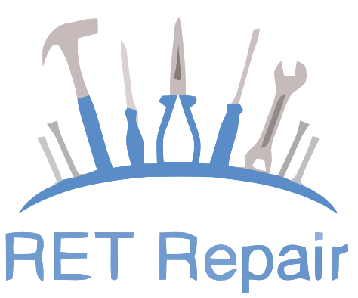

RET Repair is a website where people can order/request for repair, adjust, or install all types of electric or gas household appliances, such as refrigerators, washers, dryers, and ovens. Disassemble appliances so that problems can be diagnosed and repairs can be made.

Course: ADVANCED TOPICS IN PROGRAMMING III

Sec: A

Group Members:

|  |  |
| --- | --- |
| **Name** | **ID** |
| Saha, Rajesh | 15-29774-2 |
| Begum, Momtaz | 15-29532-2 |
| Efti, Md. Mashiul Azam Chowdhury | 15-29750-2 |